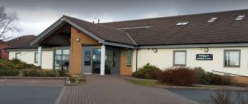
Bridgegate Medical Centre

Winchester Street
Barrow in Furness
Cumbria
LA13 9SH
Tel (01229) 820304

Lscicb-mb.bridgegatemedicalcentre@nhs.net
www.bridgegatemedicalcentre.nhs.uk

Dr J P Culling
Dr S Kapila
Dr L J Dixon
Dr R Cartmell
Dr E Griffiths
Dr S Steward
Dr K Ahmad

Practice Manager: Mr Paul Brady

Con
[Date
Specialists name
Hospital Speciality
Hospital name and address]

Dear Consultant

I am awaiting care from you for

[write your problem here]

I have been referred by my GP at Bridgegate Medical Centre.

I await an appointment and/or treatment but report the following change in my condition since my referral was sent to you:

[explain briefly what has changed since your referral]

I request that you take the following action:

• Review my hospital notes alongside this letter to determine whether my care might be expedited

• Contact me directly to inform me of the outcome of that decision, and my likely wait for further care

• File this letter and document your decision in my medical record.

Yours sincerely

[Your name]
[Your NHS number]

On behalf of Bridgegate Medical Centre

